Adding and customizing narration

Contents

Overview 1

Narration for custom programs 2

What to do to get audio working 2

Adding narration for a module page 4

Updating the Challenge Wheel narration 5

Adding narration to a modulette Refresher (mini-lesson overview) 6

Adding narration indexes to the Refresher file 6

Verifying the path name and creating an S3 directory 8

Naming Refresher audio files 9

Uploading Refresher audio files 10

Working with the audio maps 11

About audio maps 11

Creating a new audio map file 12

Removing or hiding an audio icon with the audio map 15

Hiding the audio icons for an entire modulette, module, or program 16

# Overview

By default, JUICE provides students with the option to click an audio icon and listen to narration that reads the on-screen text. This feature can be disabled at the modulette, module, or program level by editing the appropriate .json or .txt files.

If audio narration is enabled, the module pages and each step of a mini-lesson’s Overview (Refresher) display audio icon buttons that allow students to play the narration.

 

The narration is contained in mp3 files—one file for each module page group or Refresher step. The files are stored in the **narration bucket** in S3.

The S3 narration bucket has the same directory structure and naming as the S3 content bucket for content that has audio files. This allows JUICE to find the narration files that match the content. If content does not have audio files, it does not need directories in the S3 narration bucket.

JUICE finds the correct audio file to play based on its name:

* On the module page, JUICE plays the audio file called **overview.mp3** for the introduction, and files called **group_[#].mp3** for the module groups.
* In the Refreshers, the name of the audio file for each step includes the narration path and an index number specified for the step in the Refresher file.

You can over-ride JUICE’s “auto play” mode for any step in a Refresher by supplying an audio mapping which gives an alternate file name.   
  
You can also use the audio mapping to hide the audio icon for a specific Refresher step.

## Narration for custom programs

If you create a custom program, the JUICE site logic will first look in your custom program’s directory in the narration bucket for audio narration files or for an audio map. If none are found, the site will look in the core JUICE directories. If any narration files or audio maps are found with names that match your custom program, JUICE will use those.

This means that you do not need a separate set of narration files for a custom program if you are using content from core JUICE. It also means that you can update narration in a custom program without affecting core JUICE by providing updated narration files or audio maps with the appropriate names in the custom program’s narration bucket directory.

## What to do to get audio working

Here is a summary of what you might need to do and when. See below for instructions on how to set up audio for your content.

| **Your content . . .** | **What you need to do to get audio working** |
| --- | --- |
| is core JUICE content with no changes | Nothing—audio narration will be available automatically |
| is new content | For a new module, create new directories in the narration bucket that match the directories in the S3 content bucket.  Each modulette in the module needs a subdirectory within the module directory.  Your directory names and location within the directory structure must match the directory names in the S3 content bucket.  Add narration indexes to your Refresher files.  Upload audio files with the appropriate file names to their directories:   * Upload module audio to the module directory. * Upload Refresher audio files to the modulette directories. |
| Should not show the audio icons for the module | Use a setting in the file **module.txt** to hide the audio icons for the introduction, the groups, or both. Refer to “4_Customizing a JUICE module” for more info on editing a module.txt file. |
| should not show audio icon for an entire mini-lesson | Use a setting in the file **modulette.txt** to hide the audio button at the top of the page, or in the modulette steps, or both. Refer to “5_Customizing a JUICE mini-lesson” for more info on editing a modulette.txt file. |
| Is core JUICE content with changes that require new audio files | Upload replacement audio files to the appropriate narration bucket directory—make sure the audio files have the appropriate file names. |
| should not show audio icon for a specific Refresher step. | Add a mapping to hide the audio icon for that step. |

# Adding narration for a module page

To add narration for a module page, do the following:

1. Create a directory in the S3 narrations bucket for the new module. The directory name must be the same as the module’s directory name in the S3 content bucket.





1. Name your module files according to the following convention:

overview.mp3 This is the file that plays when the users click the audio icon at the top of the page.

group_1.mp3 This is the file for the first group

group_2.mp3 This is the file for the second group

etc.

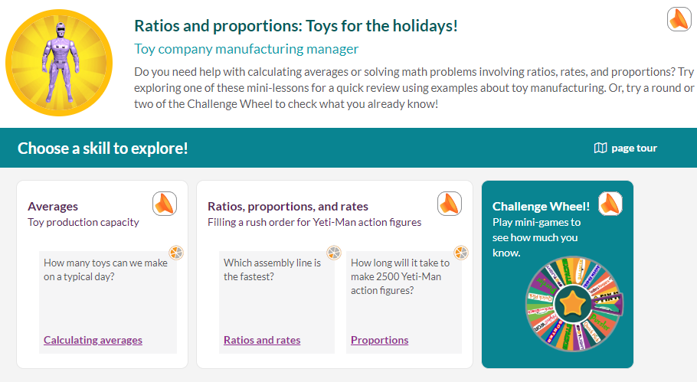

Note: The Challenge Wheel audio icon will automatically play the audio file that is the root of the narrations bucket:



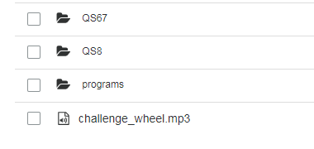

1. Upload the audio files to the module directory in the narrations bucket:



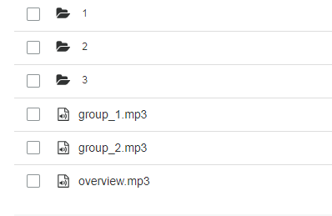

# Updating the Challenge Wheel narration

The Challenge Wheel automatically plays the audio file called challenge_wheel.mp3 that is at the root of the narrations bucket directory.

If you wish to change this narration, replace the audio file. The new file will play for ALL challenge wheel games in all modules.





# Adding narration to a modulette Refresher (mini-lesson overview)

There are four steps to adding narration to a modulette Refresher:

1. Add narration indexes to the Refresher file
2. Verify the audio path name and create the appropriate directory in the S3 narrations bucket
3. Name the audio files using the proper naming convention
4. Upload the files to the modulette’s directory in the narration bucket.

## Adding narration indexes to the Refresher file

1. To add narration indexes to a Refresher file, first access the file using the authoring tool:
   1. Access the test log-in page for your instance of JUICE at /juice/oauth_test
   2. Choose a user with a role of Admin
   3. Open the correct file authoring tool for the Refresher by putting this URL into your browser:

/juice/author/refresher_widget/[module].[modulette].[S3 filename]

Example:  
  
 /juice/author/refresher_widget/QS67.1.Refresher_Deciding_what_math_to_use

Note: This URL only works for a Refresher file. If you want to open a different type of widget file, see the documentation on *Customizing and creating new mini-lesson files* for more information.

* 1. To **preview** your changes, first **SAVE** them, and then use this URL to preview them:

/juice/preview/refresher_widget/[module].[modulette].[S3 filename]

Example:

/juice/preview/refresher_widget/QS67.1.Refresher_Deciding_what_math_to_use

1. Add numeric indexes to each step that is set to “Show Audio” and has an audio icon next to its left panel. The index goes in the field next to the Show/Hide Audio buttons.

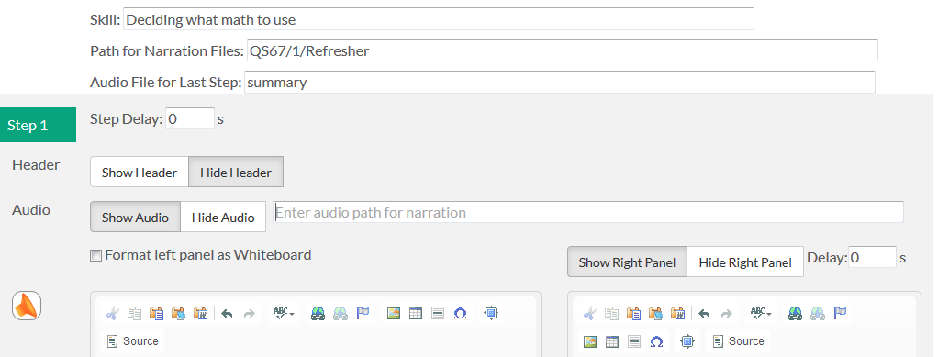

The first step of a Refresher that contains audio should have the index number 1.

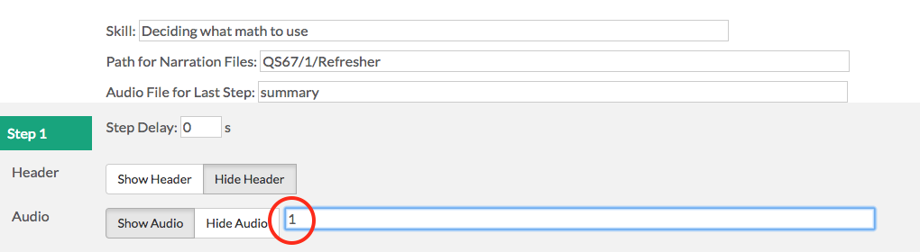

Each subsequent step that is set to Show Audio should be numbered consecutively. If a step is set to “Hide Audio,” skip it, and resume numbering with the next step containing audio.

Example:

Step 1 is set to Show Audio, so enter 1 into the audio field.

Step 2 is set to Hide Audio, so skip it.

Step 3 is set to Show Audio, so its audio index is 2.

Step 4 is set to Show Audio, so its audio index is 3.

IMPORTANT!! If you need to add steps with audio after you have already indexed the steps of the Refresher, use 1a, 1b, 1c as the inserted index numbers and in the file names. Do NOT use 1.1, 1.2, 1.3 etc. JUICE will not be able to find the associated audio files if the file names have decimal points in them.

1. Save your Refresher file.

## Verifying the path name and creating an S3 directory

The path for the narration files shows at the top of the Refresher authoring tool:



Its format should in this form:

[module id]/[modulette id]/Refresher

module id and modulette id are the names of the directories in the S3 **content** **bucket** for the module and modulette.

Example:

The narration path for a modulette in this directory should be QS67/1/Refresher:





If necessary, edit the narration file path in the Refresher file and save your changes. Create a directory for the modulette (and one for the module if needed) in the S3 **narrations bucket** with the same names.

## Naming Refresher audio files

To find audio files for a Refresher, JUICE concatenates the narrations file path specified in the Refresher with the index number of the step, and adds mp3 as the extension. The result looks like this:

QS67/1/Refresher_1.mp3

JUICE then looks in the appropriate narrations bucket directory for a file with a matching name. In the example above, JUICE will look in narrations bucket directory for module QS7, modulette 1, and try to find the file called Refresher_1.mp3

To name your file:

1. Review the Refresher in authoring mode to find the index of the step it accompanies
2. Add the index number to **Refresher_**
3. Put the extension mp3 on the end

Example:

Refresher_1.mp3

The audio file for the last or summary step of the Refresher does not have an index. Instead it should have a name that matches the text specified at the beginning of the Refresher file:



Example

Refresher_summary.mp3

Note: With this naming convention, you will have many files with the exact same names. JUICE uses the different directories in S3 to distinguish between different files with the same name.

## Uploading Refresher audio files

Your last step is to upload the properly named files to the modulette’s directory in the S3 narrations bucket:





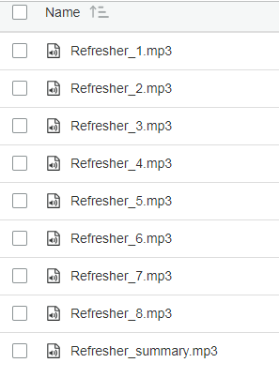

Your Refresher audio should now work! You can test it using the authoring preview mode, or preview it in the JUICE site.

# Working with the audio maps

## About audio maps

Audio maps are for the Refreshers only. An audio-map allows you to over-ride JUICE’s auto-play mode and for a specific step, telling JUICE to play a file other than the one that matches the step’s index. You can also use the audio map to hide the audio icon for a specific step.

When JUICE is playing audio for a modulette, it will look in the modulette’s narration directory for an audio map file, and use it if it exists. In a custom program, it will first look in the custom program’s narration directory, then in the matching core JUICE directory.  
  
If JUCE does not find an audio map file, then it will play in auto-play mode, finding audio file names that match the narration indexes in each step.

The audio map information for a modulette Refresher is stored in an “audio-manifest” file in the narrations bucket modulette directory:





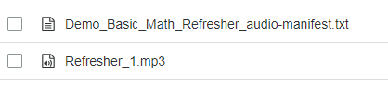

The audio map file name must contain this text; it is the text that JUICE looks for when it is looking for the audio map file in the modulette directory:

**audio-manifext.txt**

The JUICE team convention for the audio map name is as follows:

[modulette_name]_audio-manifest.txt

## Creating a new audio map file

None of the existing core JUICE modulettes use audio maps except for the test modulettes. If you need to create an audio map for an existing JUICE modulette or a new modulette, do the following:

1. Navigate to the directory D1/1 in the S3 narration bucket
2. Download the file Refresher_Basic_Math_demo_audio-manifest.txt
3. Edit it as needed with a structured editing tool such as Brackets. See the table below for information about the format of the file
4. Upload it to the appropriate modulette directory.

The parameters in the audio map file are as follows:

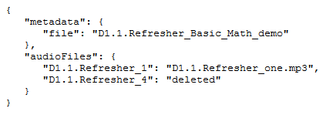

| **json parameter** | **notes** |
| --- | --- |
| metadata: file | This is the name of modulette Refresher file for which the audio map is being created.  [module id].[modulette id].[file name]   The Refresher file name begins with the module id and modulette id, which are the same as their directory names in the S3 content bucket.  These are followed by the name of the file as it appears in the S3 content bucket modulette directory.  The name for this modulette Refresher file:        Is this:  D1.1.Refresher_Basic_Math_demo.txt  If the modulette is in a custom program, the file name should reflect the complete hierarchy:  programs.chris3.e_A1.1.Refresher_Understanding_algebra |
| audio files | This section lists the default audio filenames and the replacement files that should play in their place in this format:  [default file name] : [replacement file name] |
| default file name | To find the default file name for the step you are working with:   1. Find the path for narration files at the top of the Refresher authoring tool. 2. Use this to replace the first part of the default file name in the audio-manifest.txt file, but replace the slashes (/) in the path name with dots (.)   D1/1/Refresher 🡪 D1.1.Refresher   1. Add an underscore, followed by the index number for the step.   Example:    Default file name for Step 1: D1.1.Refresher_1  Example from a custom program:    Default file name for Step 1: programs.chris3.e_A1.1.Refresher_1 |
| replacement file name | This is the name of the audio file that you want to play instead of the default file.  If the replacement file name has value of “deleted,” the audio icon will be hidden from the step.  The replacement audio file should already be uploaded to the appropriate modulette directory in the S3 narration bucket.  The replacement audio file must have a name in this form:  [module id].[modulette id].any name you like.mp3  where module id and modulette id are the names of the S3 directories to which you have uploaded the file.  Example:        Replacement audio file name:  QS67.1.Sentences.mp3  Important! You must include the mp3 file extension in the mapped name.  Replacement file names for a custom program only need the module and modulette id, because JUICE will look for the audio file within the custom program first.  Example:      Replacement audio file name  e_A1.1.Sentences.mp3  Note about custom programs: If you are using an audio map in a custom program, JUICE will first look for the replacement file in the custom program’s directory and then it will look in the narration directory for Core JUICE. If a file with the same name is found there, it will play that one.  In the example above, if you have not uploaded the file e_A1.1.Sentences.mp3 to the custom program, the Refresher widget will look in the Core JUICE narration directory for e_A1.1 to see if the file is there, and play it from there, if it is found. |

# Removing or hiding an audio icon with the audio map

To hide an audio icon with the audio mapping:

1. Create an audio mapping for a specific Refresher as described above.
2. Use the word “deleted” for the replacement file name. This is case sensitive!

Example:

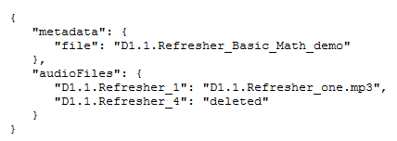

This audio mapping will hide the audio icon from the D1.1 Refresher that has an index number of **4**.

# Hiding the audio icons for an entire modulette, module, or program

To hide audio icons for an entire modulette, module, or program, you can edit the site structure files:

|  |  |  |
| --- | --- | --- |
| **To hide the audio icon for this location:** | **Edit this file in S3:** | **Parameter value to edit:** |
| Individual modulette   * Top of page * Step level | modulette.txt | Top of page: hide_audo  Step: hide_sub_audio  A value of **1** will hide the audio |
| Individual module   * Introductory section * Group level | module.txt | Intro: hide_audio  Group: hide_sub_audio  A value of **1** will hide the audio |
| ALL modules or modulettes in the core JUCE program | /components/program-value/program-value-defaults.json  This is part of the site code and is not stored in S3. | A value of **true** will hide the audio |
| ALL modules or modulettes in a custom program | programs/[custom program]/program.json | A value of **true** will hide the audio |